Balsamic-Rosemary Vinaigrette
- 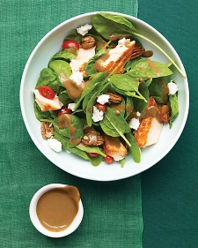
Balsamic gets a brief blitz in the blender with rosemary, mustard, and garlic in this quick-to-make dressing that doubles as a marinade.
Everyday Food, March 2009
- Yield Makes 3/4 cup

Ingredients
- 1/3 cup balsamic vinegar
- 1 tablespoon Dijon mustard
- 1 small garlic clove
- 1 tablespoon fresh rosemary leaves (or 1/4 teaspoon dried)
- 2 tablespoons water
- 1/2 teaspoon coarse salt
- 1/4 teaspoon ground pepper
- 1/2 cup extra-virgin olive oil

Directions
- In a blender, combine vinegar, mustard, garlic, rosemary, water, salt, and pepper. Blend until smooth. With machine running, add oil in a thin stream; blend until creamy.

Cook's Note
A clean jam jar is perfect for storing dressings like our balsamic vinaigrette.

Basil Vinaigrette

Ingredients
Original recipe makes 1 -1/2 cups
1 cup olive oil
- 1/3 cup apple cider vinegar
- 1/4 cup honey
- 3 tablespoons chopped fresh basil
- 2 cloves garlic, minced
Check All Add to Shopping List

Directions
- In a bowl, whisk together the olive oil, apple cider vinegar, honey, basil, and garlic. Pour over or toss with your favorite salad to serve.

